

**GREEN PEACE ACADEMY**

A Lab Report On ……………………………………

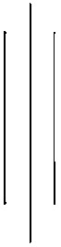

Submitted by: Ashish Uraw

Submitted to: Pujan Sir

**Computer Science Department**

22 Falgun, 2081

**Lab report: Chapter 1- DBMS**

a. Create a database named ‘computer_science’.

CREATE DATABASE computer_science ;

**Explanation:**  
This statement creates a new database called computer_science. After executing this command, we'll have an empty database ready for use.

b. Create a table named ‘Students’ under the database ‘computer_science’ and insert any 5 records:

USE computer_science;

CREATE TABLE Students (

RollNumber INT PRIMARY KEY,

Name VARCHAR(100),

Gender VARCHAR(10),

Address VARCHAR(255),

Contact VARCHAR(15)

);

INSERT INTO Students (RollNumber, Name, Gender, Address, Contact)

VALUES

(1, 'Amit Sharma', 'Male', 'Kathmandu', '9812345678'),

(2, 'Ayesha Koirala', 'Female', 'Pokhara', '9812345679'),

(3, 'Anil Pandey', 'Male', 'Bhaktapur', '9812345680'),

(4, 'Arpita Shah', 'Female', 'Lalitpur', '9812345681'),

(5, 'Amit Kumar', 'Male', 'Chitwan', '9812345682');

**Explanation:**

* CREATE TABLE Students creates the table with columns: RollNumber, Name, Gender, Address, and Contact.
* INSERT INTO Students adds 5 records with different values for each column (e.g., RollNumber, Name, Gender, etc.).

**c. Display all the records:**

To display all records in the Students table, we can use the SELECT statement:

SELECT * FROM Students;

**Explanation:**  
The SELECT * command fetches all the columns and all the records from the Students table.

**d. Display the Record of the students whose name starts with ‘A’:**

To filter records based on names starting with ‘A’, we can use the LIKE operator:

SELECT * FROM Students

WHERE Name LIKE 'A%';

**Explanation:**

* LIKE 'A%' finds records where the Name starts with the letter ‘A’. The % symbol is a wildcard that matches any sequence of characters following the letter ‘A’.

**Chapter 3: Web Technology-II JavaScript**

<!DOCTYPE html>

<html lang="en">

<head>

<title>Odd or Even Checker</title>

</head>

<body>

<h2>Odd or Even Checker</h2>

<label for="numberInput">Enter a number: </label>

<input type="number" id="numberInput" placeholder="Enter a number">

<button onclick="checkEvenOdd()">Check</button>

<p id="result"></p>

<script>

// Function to check if the number is odd or even

function checkEvenOdd() {

// Get the value from the input field

let number = document.getElementById("numberInput").value;

// Check if the number is even or odd

if (number % 2 === 0) {

document.getElementById("result").textContent = number + " is Even";

} else {

document.getElementById("result").textContent = number + " is Odd";

}

}

</script>

</body>

</html>

Output:

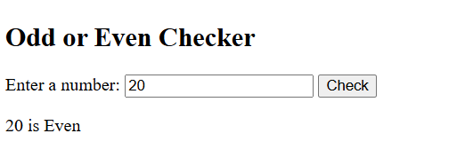

2. Write JavaScript program that prints out the largest number among three entered numbers.

<!DOCTYPE html>

<html lang="en">

<head>

<meta charset="UTF-8">

<meta name="viewport" content="width=device-width, initial-scale=1.0">

<title>Find Largest Number</title>

</head>

<body>

<h2>Largest Number Finder</h2>

<label for="num1">Enter first number: </label>

<input type="number" id="num1" placeholder="First number"><br><br>

<label for="num2">Enter second number: </label>

<input type="number" id="num2" placeholder="Second number"><br><br>

<label for="num3">Enter third number: </label>

<input type="number" id="num3" placeholder="Third number"><br><br>

<button onclick="findLargest()">Find Largest</button>

<p id="result"></p>

<script>

function findLargest() {

// Get input values

let num1 = parseFloat(document.getElementById("num1").value);

let num2 = parseFloat(document.getElementById("num2").value);

let num3 = parseFloat(document.getElementById("num3").value);

// Validate input

if (isNaN(num1) || isNaN(num2) || isNaN(num3)) {

document.getElementById("result").textContent = "Please enter valid numbers.";

return;

}

// Find the largest number

let largest = Math.max(num1, num2, num3);

// Display result

document.getElementById("result").textContent = "The largest number is: " + largest;

}

</script>

</body>

</html>

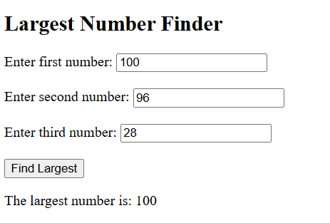Output:

# 3. Write JavaScript code to calculate the factorial of a number

<!DOCTYPE html>

<html lang="en">

<head>

<title>Factorial Calculator</title>

</head>

<body>

<h2>Factorial Calculator</h2>

<form onsubmit="event.preventDefault(); calculateFactorial();">

<input type="number" id="num" placeholder="Enter a number" min="0">

<button type="submit">Calculate</button>

</form>

<p id="result"></p>

<script>

function factorial(n) {

return (n === 0 || n === 1) ? 1 : n * factorial(n - 1);

}

function calculateFactorial() {

let num = parseInt(document.getElementById("num").value);

let result = (isNaN(num) || num < 0) ? "Enter a valid non-negative number." :

`Factorial of ${num} is: ${factorial(num)}`;

document.getElementById("result").textContent = result;

}

</script>

</body>

</html>

Output:

# 4. Write JavaScript program that calculates the sum of any two entered numbers.

<!DOCTYPE html>

<html lang="en">

<head>

<title>Sum of Two Numbers</title>

</head>

<body>

<h2>Sum Calculator</h2>

<form onsubmit="event.preventDefault(); calculateSum();">

<input type="number" id="num1" placeholder="Enter first number">

<input type="number" id="num2" placeholder="Enter second number">

<button type="submit">Calculate Sum</button>

</form>

<p id="result"></p>

<script>

function calculateSum() {

let num1 = parseFloat(document.getElementById("num1").value);

let num2 = parseFloat(document.getElementById("num2").value);

let result = (isNaN(num1) || isNaN(num2)) ? "Enter valid numbers." :

`Sum: ${num1 + num2}`;

document.getElementById("result").textContent = result;

}

</script>

</body>

</html>

Output:

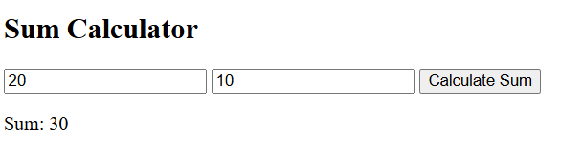

5. Write down server side script using php to PHP